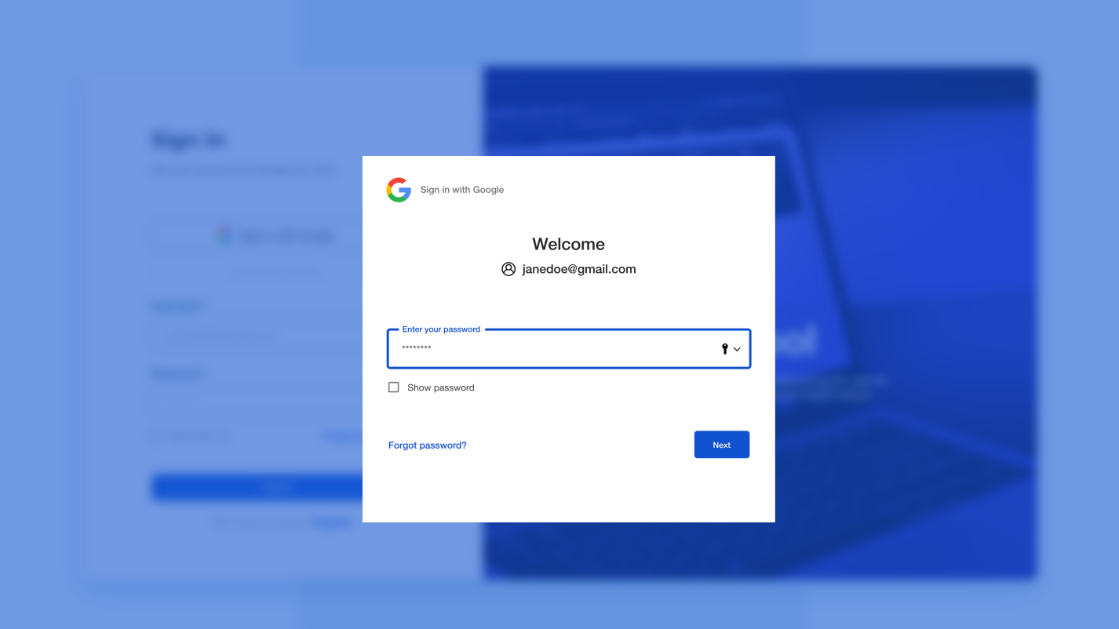

\*After clicking log in, you will be redirected to the dashboard.

\*\*After clicking Forgot password link, you will be redirected to the forgot password page.

\*\*\*After clicking Register link, you will be redirected to the Sign up form.

\*

\*\*\*

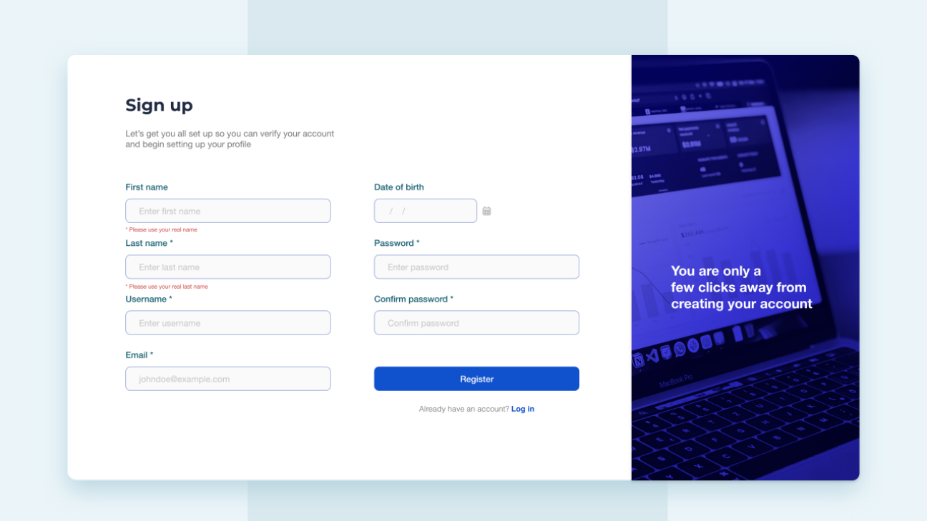

Email confirmation

